STRR DEMONSTRATION REPORT – 1
Seed to Harvest
Details Of Farmer
Name of Farmers | Dhirigraj singh
Mobile No. | 9508998957
Village Name | Kushdihra
Block & Tehsil | Tilouthu
District & State | Rohtash

Field And Crop Detail
Total Acreage(acre) | 30 ACRE
Crops Grown | 30 ACRE
Field Location (Easy approach/road side) | ROAD SIDE
Selected - Crop & Variety | PADDY MTU-7029
Trial Plot Area (KATHA) | 16 KATHA
Seed Rate (kg/acre) | 300 ml/acre
Sowing Date | 11.07.2025

Demo Product Name And Dose& Field day detail
Name of Product | LEXON+VEERCOMBI- 505
Application Dose (ml/acre) | 150 ml/Acre
Date/Time of Application | 22.09.2025

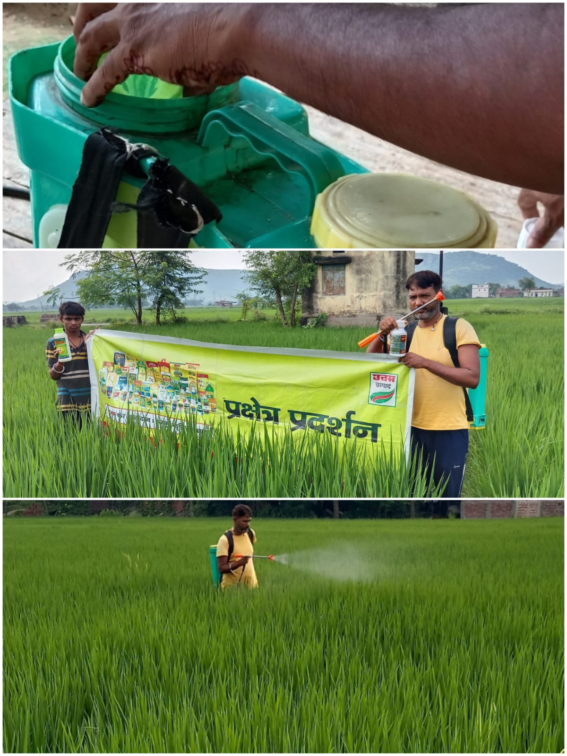

STRR DEMONSTRATION REPORT – 2
Seed to Harvest
Details Of Farmer
Name of Farmers | Basant mehta
Mobile No. | 9576956016
Village Name | Sewahi
Block & Tehsil | Tilouthu
District & State | Rohtash

Field And Crop Detail
Total Acreage(acre) | 10 ACRE
Crops Grown | 10 ACRE
Field Location (Easy approach/road side) | ROAD SIDE
Selected - Crop & Variety | PADDY MTU-7029
Trial Plot Area (KATHA) | 16 KATHA
Seed Rate (kg/acre) | 300 ml/acre
Sowing Date | 11.07.2025

Demo Product Name And Dose& Field day detail
Name of Product | LEXON+VEERCOMBI- 505
Application Dose (ml/acre) | 150 ml/Acre
Date/Time of Application | 18.09.2025

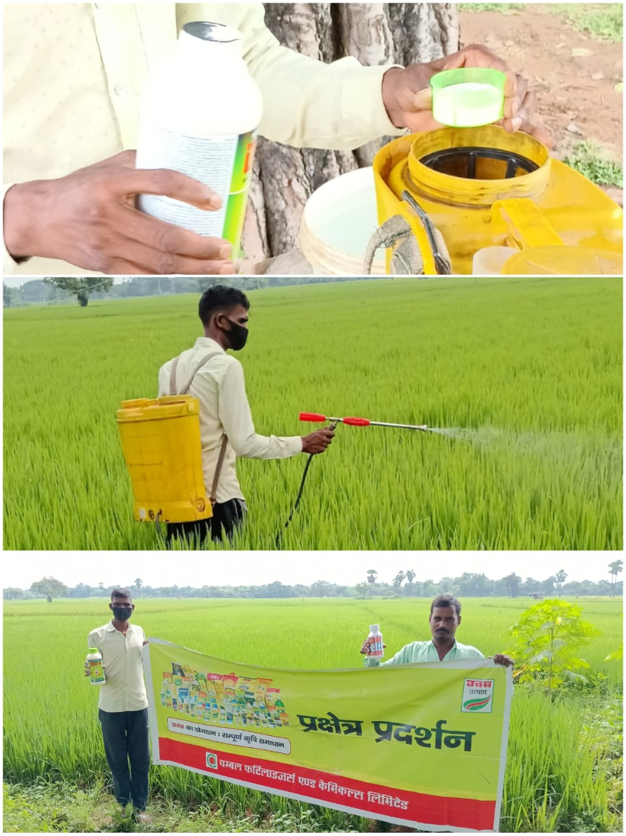

STRR DEMONSTRATION REPORT – 3
Seed to Harvest
Details Of Farmer
Name of Farmers | Sudarshan singh
Mobile No. | +917903550131
Village Name | Rendia
Block & Tehsil | chenari
District & State | ROHTASH

Field And Crop Detail
Total Acreage(acre) | 15 ACRE
Crops Grown | 15 ACRE
Field Location (Easy approach/road side) | ROAD SIDE
Selected - Crop & Variety | PADDY MTU-7029
Trial Plot Area (KATHA) | 16 KATHA
Seed Rate (kg/acre) | 300 ml/acre
Sowing Date | 07.07.2025

Demo Product Name And Dose& Field day detail
Name of Product | LEXON+VEERCOMBI- 505
Application Dose (ml/acre) | 150 ml/Acre
Date/Time of Application | 24.09.2025

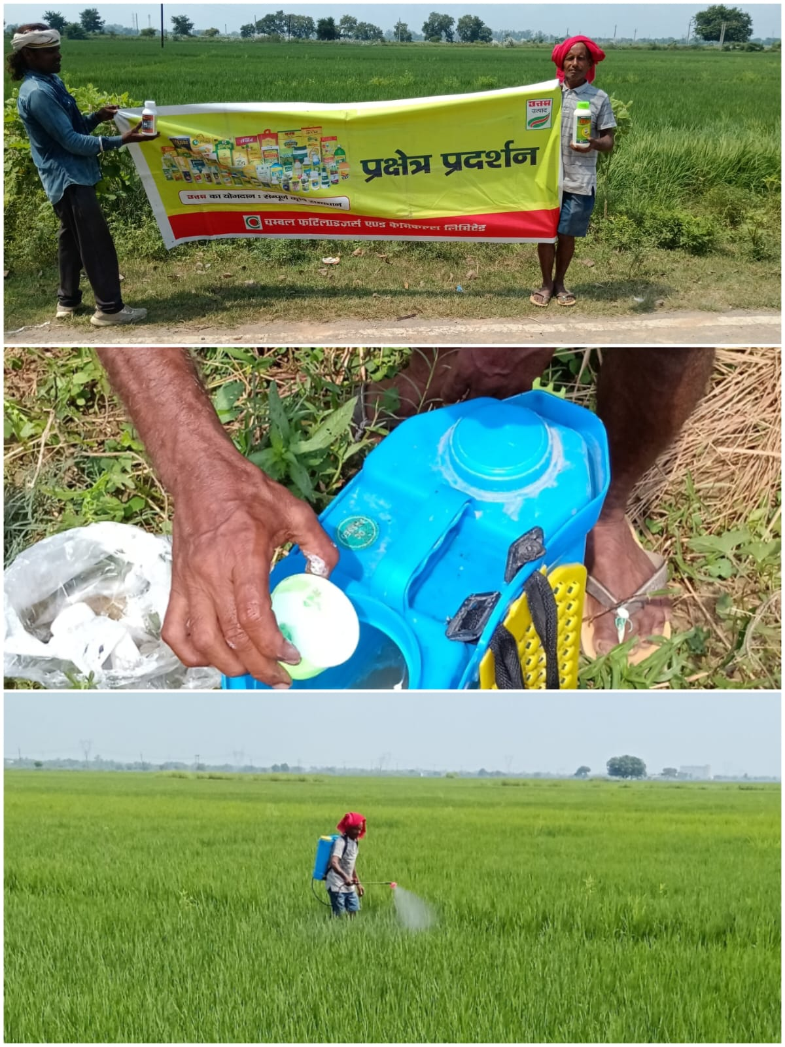

STRR DEMONSTRATION REPORT – 4
Seed to Harvest
Details Of Farmer
Name of Farmers | Hajari ram
Mobile No. | 9199902811
Village Name | Tenduni
Block & Tehsil | chenari
District & State | ROHTASH

Field And Crop Detail
Total Acreage(acre) | 15 ACRE
Crops Grown | 15 ACRE
Field Location (Easy approach/road side) | EASY APPROCH
Selected - Crop & Variety | PADDY MTU-7029
Trial Plot Area (KATHA) | 16 KATHA
Seed Rate (kg/acre) | 300 ml/acre
Sowing Date | 13.07.2025

Demo Product Name And Dose& Field day detail
Name of Product | LEXON+VEERCOMBI- 505
Application Dose (ml/acre) | 150 ml/Acre
Date/Time of Application | 19.09.2025

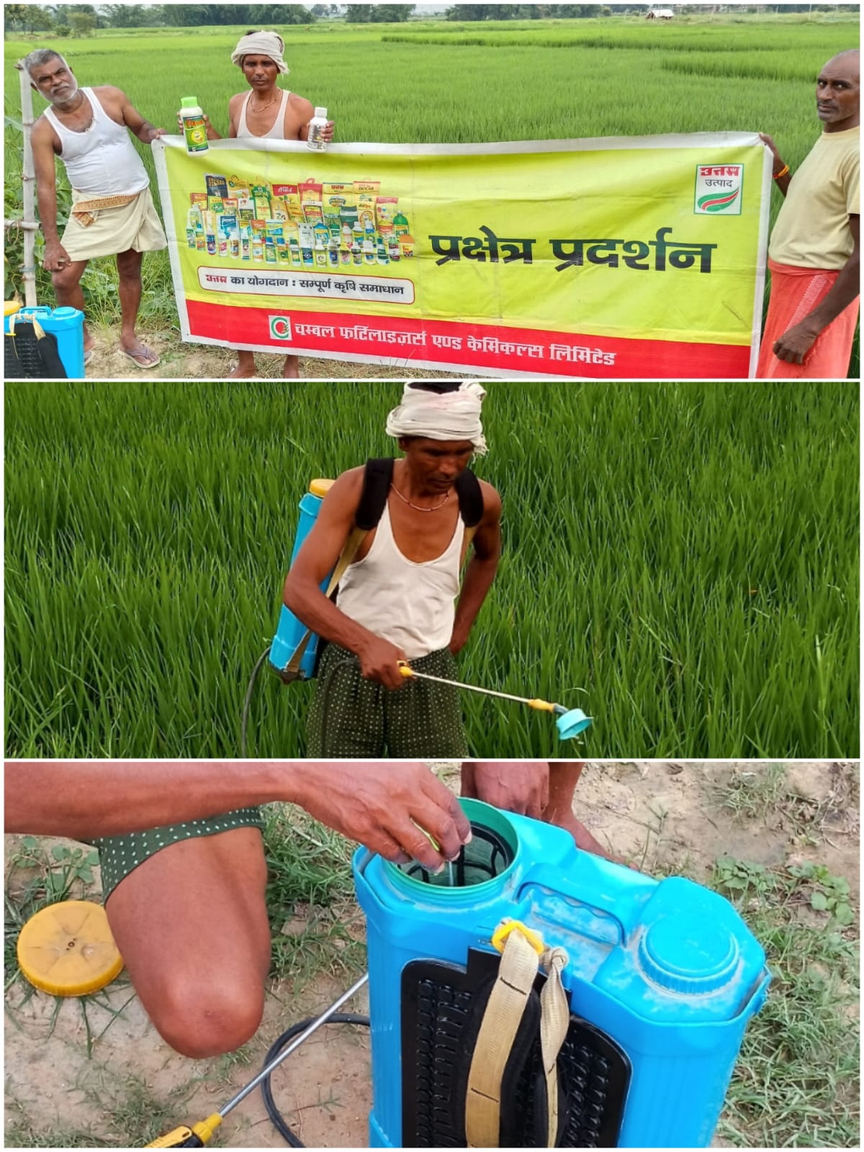

STRR DEMONSTRATION REPORT – 5
Seed to Harvest
Details Of Farmer
Name of Farmers | Laxman Singh
Mobile No. | 9771199159
Village Name | Nawadih
Block & Tehsil | Tilouthu
District & State | ROHTASH

Field And Crop Detail
Total Acreage(acre) | 25 ACRE
Crops Grown | 25 ACRE
Field Location (Easy approach/road side) | ROAD SIDE
Selected - Crop & Variety | PADDY MTU-7029
Trial Plot Area (KATHA) | 16 KATHA
Seed Rate (kg/acre) | 300 ml/acre
Sowing Date | 19.07.2025

Demo Product Name And Dose& Field day detail
Name of Product | LEXON+VEERCOMBI- 505
Application Dose (ml/acre) | 150 ml/Acre
Date/Time of Application | 22.09.2025

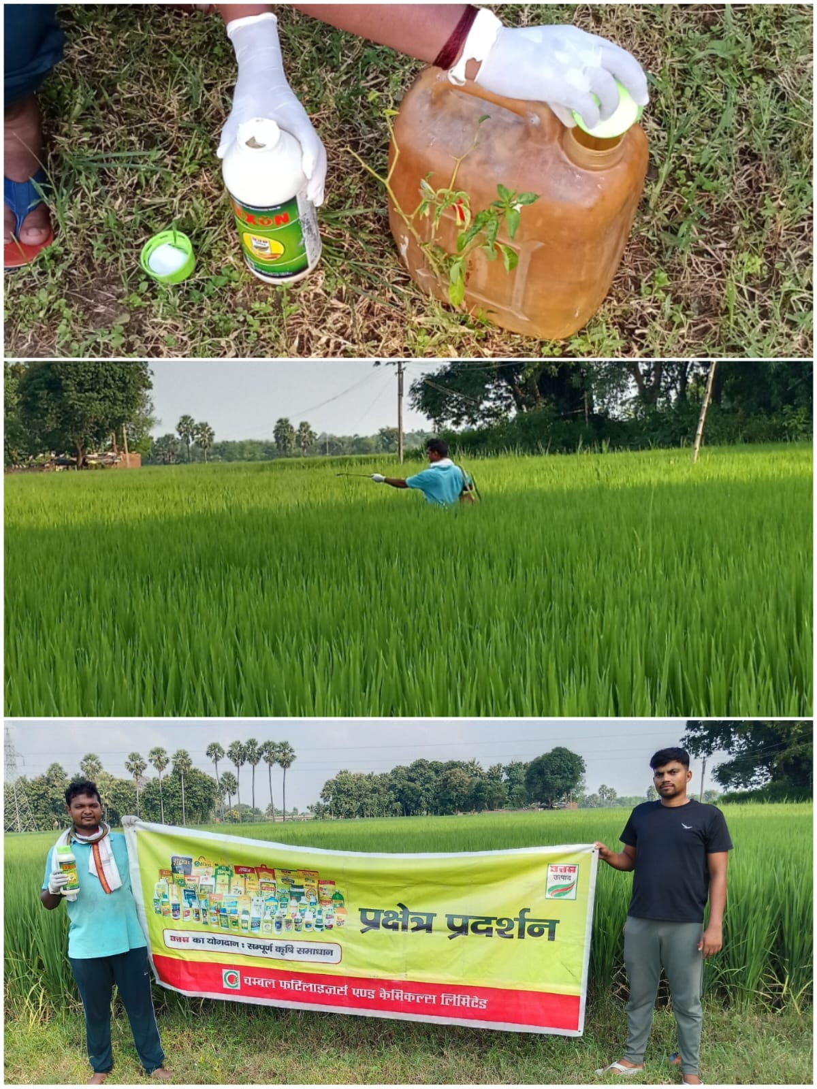
STRR DEMONSTRATION REPORT – 6
Seed to Harvest
Details Of Farmer
Name of Farmers | Lalbabu kumar
Mobile No. | 8002580310
Village Name | Shahpur
Block & Tehsil | chenari
District & State | ROHTASH

Field And Crop Detail
Total Acreage(acre) | 20 ACRE
Crops Grown | 20 ACRE
Field Location (Easy approach/road side) | EASY APPROACH
Selected - Crop & Variety | PADDY MTU-7029
Trial Plot Area (KATHA) | 16 KATHA
Seed Rate (kg/acre) | 0300 ml/acre
Sowing Date | 06.07.2025

Demo Product Name And Dose& Field day detail
Name of Product | LEXON+VEERCOMBI- 505
Application Dose (ml/acre) | 150 ml/Acre
Date/Time of Application | 24.09.2025

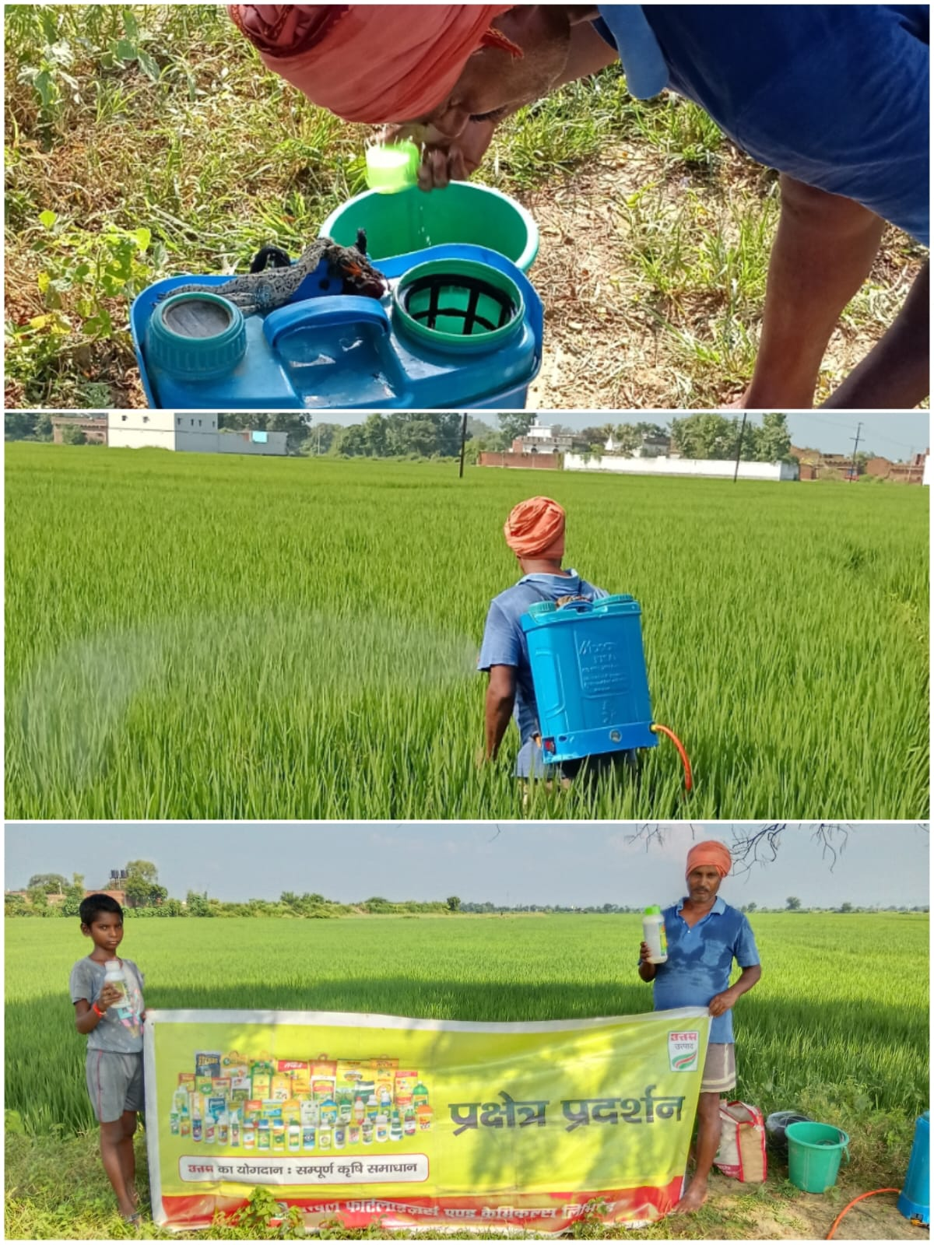

STRR DEMONSTRATION REPORT – 7
Seed to Harvest
Details Of Farmer
Name of Farmers | Mithlesh kumar Mehta
Mobile No. | 9060047273
Village Name | Chanka
Block & Tehsil | Nokha
District & State | ROHTASH

Field And Crop Detail
Total Acreage(acre) | 08 ACRE
Crops Grown | 08 ACRE
Field Location (Easy approach/road side) | ROAD SIDE
Selected - Crop & Variety | PADDY MTU-7029
Trial Plot Area (KATHA) | 16 KATHA
Seed Rate (kg/acre) | 0300 ml/acre
Sowing Date | 12.07.2025

Demo Product Name And Dose& Field day detail
Name of Product | LEXON+VEERCOMBI- 505
Application Dose (ml/acre) | 150 ml/Acre
Date/Time of Application | 27.09.2025
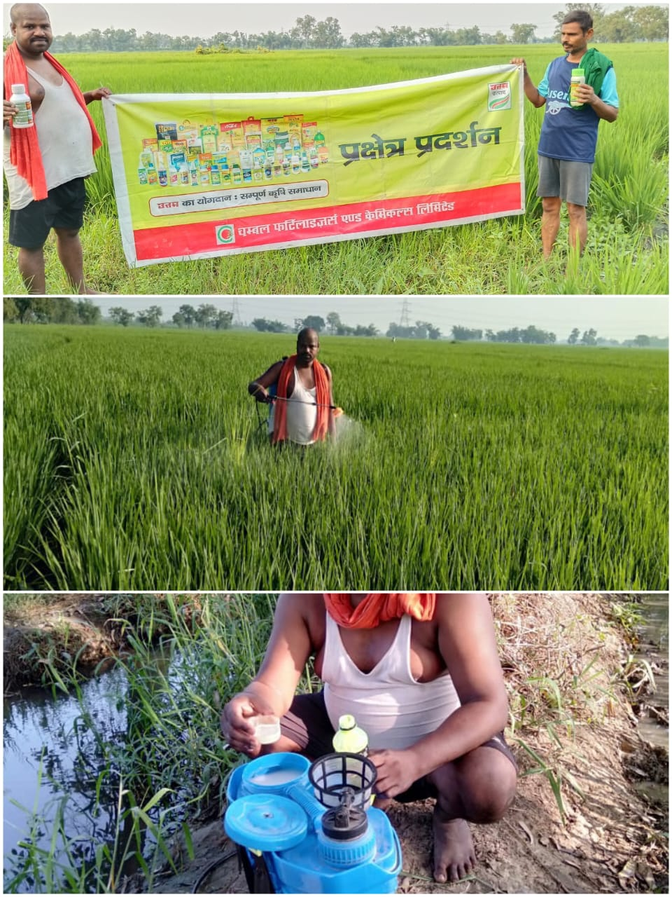

STRR DEMONSTRATION REPORT – 8
Seed to Harvest
Details Of Farmer
Name of Farmers | satynarayan singh
Mobile No. | 9939314979
Village Name | Huruka
Block & Tehsil | Tilouthu
District & State | ROHTASH

Field And Crop Detail
Total Acreage(acre) | 05 ACRE
Crops Grown | 05 ACRE
Field Location (Easy approach/road side) | EASY APPROCH
Selected - Crop & Variety | PADDY MTU-7029
Trial Plot Area (KATHA) | 16 KATHA
Seed Rate (kg/acre) | 300 ml/acre
Sowing Date | 11.07.2025

Demo Product Name And Dose& Field day detail
Name of Product | LEXON+VEERCOMBI- 505
Application Dose (ml/acre) | 150 ml/Acre
Date/Time of Application | 27.09.2025

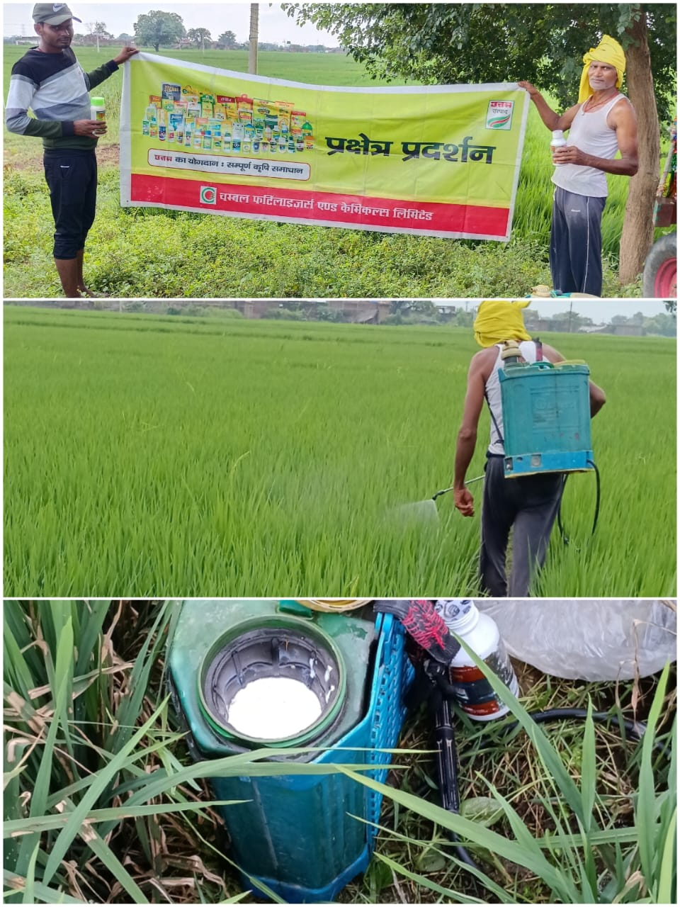

STRR DEMONSTRATION REPORT – 9
Seed to Harvest
Details Of Farmer
Name of Farmers | Shivmuni Yadav
Mobile No. | 9801779993
Village Name | Baradih
Block & Tehsil | Tilouthu
District & State | ROHTASH

Field And Crop Detail
Total Acreage(acre) | 8 ACRE
Crops Grown | 8 ACRE
Field Location (Easy approach/road side) | EASY APPROCH
Selected - Crop & Variety | PADDY MTU-7029
Trial Plot Area (KATHA) | 16 KATHA
Seed Rate (kg/acre) | 300 ml/acre
Sowing Date | 05.07.2025

Demo Product Name And Dose& Field day detail
Name of Product | LEXON+VEERCOMBI- 505
Application Dose (ml/acre) | 150 ml/Acre
Date/Time of Application | 23.09.2025
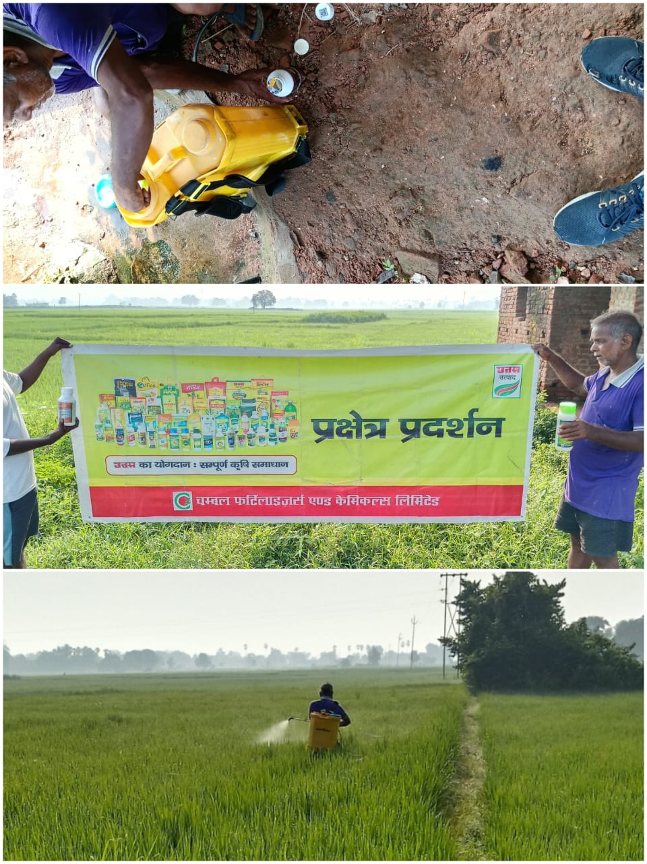

STRR DEMONSTRATION REPORT – 10
Seed to Harvest
Details Of Farmer
Name of Farmers | Dharmendra ram
Mobile No. | 8221969402
Village Name | Harnachiti
Block & Tehsil | Tilouthu
District & State | ROHTASH

Field And Crop Detail
Total Acreage(acre) | 8 ACRE
Crops Grown | 8 ACRE
Field Location (Easy approach/road side) | EASY APPROCH
Selected - Crop & Variety | PADDY MTU-7029
Trial Plot Area (KATHA) | 16 KATHA
Seed Rate (kg/acre) | 300 ml/acre
Sowing Date | 05.07.2025

Demo Product Name And Dose& Field day detail
Name of Product | LEXON+VEERCOMBI- 505
Application Dose (ml/acre) | 150 ml/Acre
Date/Time of Application | 27.09.2025

